Week4 work

Exercise 15

I looked into what MAE(Mean absolute error) and MSE( Mean squared error) are. They are used to evaluate the regression problem’s accuracy.

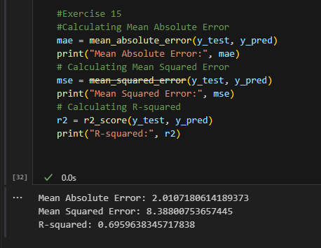

Exercise 16

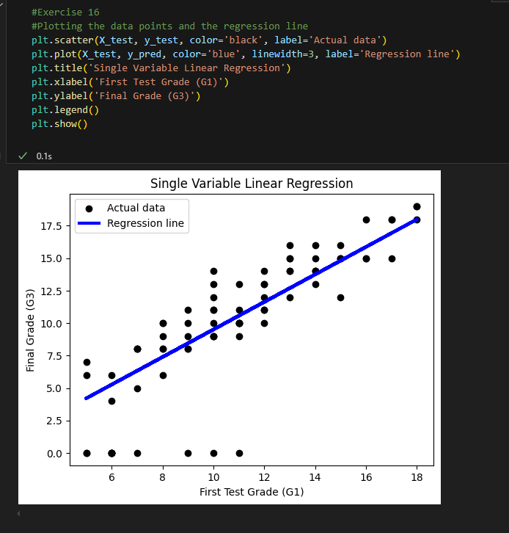

Exercise 19

These are the data types that we have.

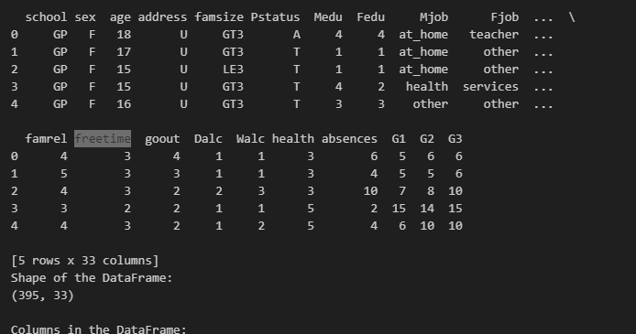

I compared **free time** to the **final grade**, and it seems that the data didn’t have a great accuracy.

Mean Absolute Error: 4.120199069566159

Mean Squared Error: 27.694604563167537

R-squared: -0.0038333105593415517

I used the plot, and it seems that there is a slight regression.

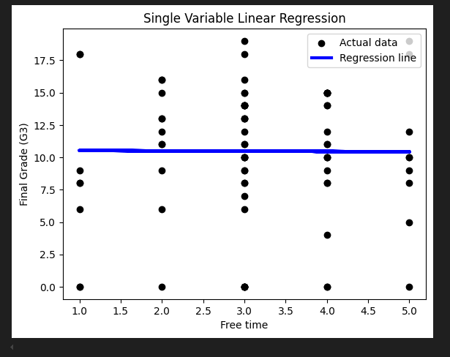

I am looking if people with absences had more free time, but it seems that it didn’t make a big difference

Mean Absolute Error: 0.8943254091405475

Mean Squared Error: 1.2386065278202987

R-squared: -0.003914719496945773

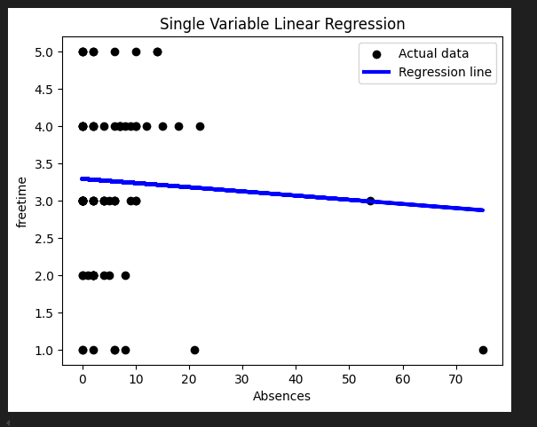

I am looking to see if the second Grade has any impact.

Mean Absolute Error: 1.3260063744973654

Mean Squared Error: 5.63653417115305

R-squared: 0.7956951960009399

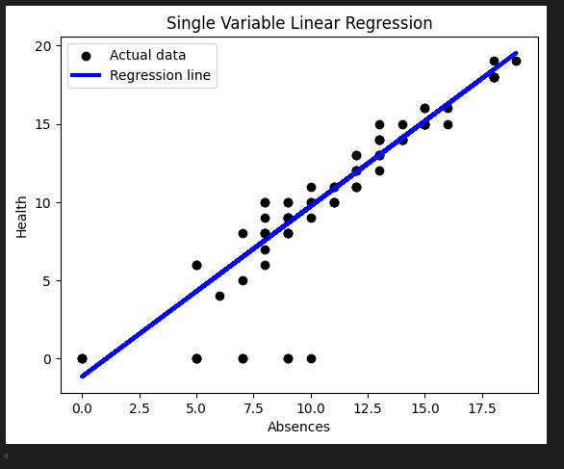

And it seemed to correlate.